Online Shopping System: FootFusion

Use-Case Specification: Manage Products -
Add Products

Version <1.0>

Revision History
Date | Version | Description | Author
<23/11/2024> | <1.0> | Final Draft | Dao Ngoc Quang

Table of Contents
1. Add Products 4
1.1 Brief Description 4
1.2 Actor 4
2. Flow of Events 4
2.1 Basic Flow 4
2.2 Alternative Flows 5
2.2.1 The seller cancels adding a product. 5
2.2.2 Each field of product information cannot be empty. 5
3. Special Requirements 5
4. Preconditions 5
5. Postconditions 5
6. Extension Points 5
7. Prototype 5

Use-Case Specification: Add Products

Add Products

Brief Description
The "Add Products" use case enables a FootFusion buyer to input details for one or more products, including name, price, quantity, and additional attributes.

Actor
FootFusion Buyer

Flow of Events
The buyer navigates to the "Products" section using the sidebar menu. By selecting the "Add Product" option, they can specify product filters. The selected product is then added to the buyer's cart. After clicking the "Confirm" button, all product details are saved to the database, and the system redirects the buyer to the product information page. Buyers can also navigate through pages to view additional product as needed.
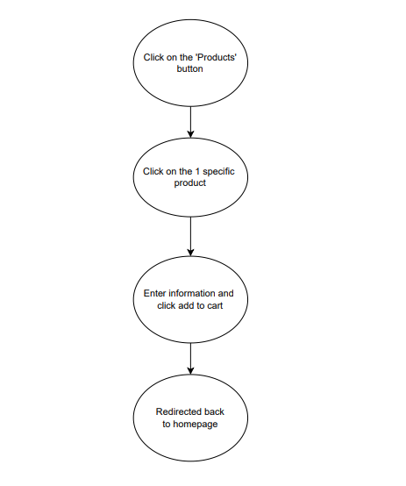

Alternative Flows

Canceling the Product Addition

At any point before the buyer enters product information, they may click the "Back" button to cancel the process. The use case ends. Each product information field must be completed to proceed

Incomplete Product Information.

If the buyer attempts to save product details with any field left blank, the system will display an error message and prompt the buyer to fill in the missing information.

Special Requirements
There are no special requirements.

Preconditions
There are no preconditions.

Postconditions
A product is added and saved successfully for the buyer to view.

Extension Points
There is no extension point.

Prototype

- 